

Corporate credit card request

Remedyforce Service Request

|  |
| --- |
| Disclaimer  While we have made every attempt to ensure that the information in this document has been obtained from reliable sources, Bluepineapple is not responsible for any errors or omissions, or for the results obtained from the use of this information. All information in this document is provided “as is”, with no guarantee of completeness, accuracy, timeliness or of the results obtained from the use of this information, and without warranty of any kind, express or implied, including but not limited to warranties of performance, merchantability, and fitness for a particular purpose. In no event will Bluepineapple or its related corporations be liable for any decision or action taken in reliance on the information in this document for any consequential, special, or similar damages, even if advised of the possibility of such damages.  All product names, trademarks and registered trademarks are property of their respective owners. All company, product and service names used in this website are for identification purposes only. Use of these names, trademarks and brands does not imply endorsement |

.

Contents

1. Executive Summary 2

2. Service Request Form 3

2.1. Form 3

2.2. Form Field Details 4

3. Templates 5

3.1. Incident Templates 5

3.2. Request Detail Templates 5

4. Categories 6

5. Approval Process 7

5.1. Approval from SSP 7

5.2. Approval from Console 8

6. Queue and Queue Members 9

7. Notifications 11

8. Email Templates 12

8.1. Notify Finance Queue that a service request has been created. 12

8.2. Notify Staff Member that a service request has been created or reassigned 12

9. System Settings 13

9.1. Accounts 13

9.2. Permission Set 13

1. Executive Summary

This document lists the configurations made in Remedyforce to build a Corporate Credit Card Service Request which then can be utilized by Konica Minolta internal managers Finance Team when an employee needs a corporate credit card.

This document is considered as a baseline reference for configuring the Service Request in ServiceNow.

Any changes discussed during the workshop are included and amendments are highlighted in the documents.

1. Service Request Form
   1. Form

List of all the key details captured when initiating a corporate credit card request service request.

Replace access form with Application Form in the screenshot below.

* 1. Form Field Details

List of fields which are introduced on the service request to capture details regarding corporate credit card request.

Replace the prompt on the form with “Please Submit the request to receive the Corporate Credit Card Application Form”

|  |  |  |  |  |  |
| --- | --- | --- | --- | --- | --- |
| **Prompt/Question** | **Response Type** | **Required** | **Column** |  | **Comments** |
| Please Submit the request to receive the Corporate Credit Card access form. | Header Section |  |  |  |  |

1. Templates
   1. Incident Templates

Incident template will populate the impact, urgency, category, and queue on the service request.

Mostly the template won’t be visible on the screen, but we will replace the template name and description to “Corporate Credit Card Application Request”.

|  |  |  |  |  |  |  |
| --- | --- | --- | --- | --- | --- | --- |
| **Template Name** | **Is New Service Request** | **Queue** | | **Impact** | **Urgency** | **Description** |
| Corporate Credit Card Application Request | True | Finance | 2.Middle | | 2. Middle | This is a service request for Corporate Credit Card Access. |

1. Categories

As a part for this service request, following will be the category tree

1. Approval Process

Once the Service Request is requested, it is automatically submitted for Approval via approval process to Finance members. If any of the Finance member rejects the request, client can edit the request as per the approver’s comments and he/she can resubmit the request. It will be automatically submitted for approval once again.

**(**Note: If Request is raised by Finance Team, Service Request is Auto Approved.)**

1. Queue and Queue Members

**Finance:**

|  |  |
| --- | --- |
| Sr. No | Team Members |
| 1. | ~~Bernadette Filippello~~ |
| 2. | ~~Commissions~~ |
| 3. | Humaira Kabir |
| 4. | Teresa |

1. Notifications

System will send notifications to Staff & Queue (which includes Teresa and Humaira)

|  |  |  |
| --- | --- | --- |
| **Workflow/Approval** | **Email Template** | **Description** |
| Notify Queue member when SR is created or reassigned | Notify Queue Members when Service Request is created | Whenever a Corporate Credit Card Service Request will be created, this workflow will notify the Finance queue. |
| Notify the Staff member when SR is assigned or reassigned | Notify Staff when Service Request is assigned | Whenever a staff is populated or updated onto service request this workflow will send out an email notification to the assigned staff. |

1. Email Templates

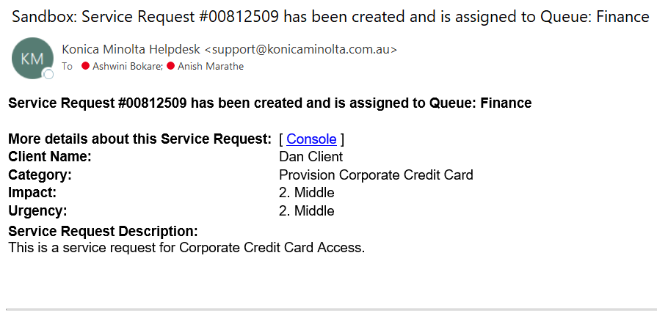8.1. Notify Finance Queue that a service request has been created.

8.2. Notify Staff Member that a service request has been created or reassigned.

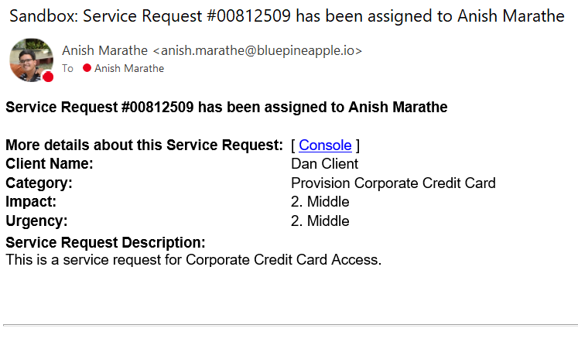

Approved Email template

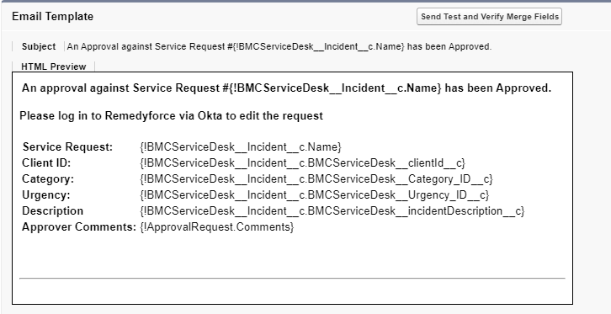

Rejected Email Template

1. System Settings

9.1. Accounts

All the internal Konica Minolta employees would be associated to BAU Internal Account in the system.

9.2. Permission Set

The Corporate Credit Card Request is available for manager and Finance Team members via Permission Set.

A custom permission set **“Permission to Service Request”** has been created and assigned to the users.

This request is applicable to Managers only and non-manager users under specific circumstance.